Photo 1:
This is a photo of myself looking in a mirror at 13th Avenue Coffee House in Regina.

I have sat at the table underneath the mirror, yet I have never noticed it before. Perhaps I thought it was a painting or was so focused on the person I was with or the homework that I was doing to notice the mirror. This shows me how unobservant I really am! However, today I sat at a bigger table across from the table in this photo to do homework with my sister. This forced me to have a new perspective on my surroundings. I think this represents how sometimes I need to take a step back to notice my surroundings, others and my beliefs. By noticing the mirror, I have acknowledged something that the owners have put on the wall to be admired, I have fulfilled the mirror’s intended purpose to be noticed. As well, the mirror has offered me a different perspective, quite literally, to see myself in. By seeing myself through a mirror I can either notice myself to be beautiful or critique myself, I can consciously choose to treat myself kindly and notice, or not notice, my beauty. I think I should always choose to notice my beauty to make myself feel good about myself, which I deserve to feel. My gaze and thoughts about what I see (myself or students, etc.) can change the person/item.

I see someone in the mirror who is fairly confident in who I am, especially in what I wear to express myself. I see someone who enjoys being able to wear what I want in public, to school and while teaching, within reason. This may be an outcome of being told what I cannot wear. For example, during my high school experience girls were not allowed to show their bra straps, wear spaghetti strap tank tops, show their bare upper chest or wear shorts above our finger tips when my arms were at my side. This all seemed unfair because I could not control how hot it was outside or in the building, the fact that I wore a bra or how long my arms and legs were, which made my shorts look short. As well, I should not be made responsible for what did or did not attract adolescent boys’ attention. Schooling controlled and shamed my sexuality. Gilbert (2014) writes,
“the fates of sexuality and education as intertwined; there can be no thought of sexuality without invocations of schooling, upbringing, civilizing, and all the procedures we imagine are necessary to call an unsocialized sexuality into the fold of human society. Similarly, there can be no thought of education without the propulsive charge of sexuality enabling and disturbing the work of teaching and learning.” (p. xiv-xv)
This photo illustrates to me how education and sexuality intertwined and have affected me to this day in how I present myself and what I choose to wear. Furthermore, what I usually choose to wear is typical female/feminine clothing, as dictated by society, such as in this photo. Since I am perceived to be “homosexual whose gender conforms more to the norm [I] can often be silently accepted” (Warner, 1999, p. 37). This reinforces the fact that I am able to wear what I want without fear of being shamed; however, this was not the case in high school due to the dress code that was decided for me in fear of sexuality by the teachers.

I also noticed that the mirror is distressed on its edges. Perhaps this is symbolic that every person, including myself, is a little rough on the edges, and has insecurities and imperfections, but we are still all human. Although I am noticing these imperfections of the mirror now, I did not notice it until later looking at the photo. Perhaps this delayed observation shows my nature to notice the mirror as a whole and not its flaws. This may be translated into my job as a teacher, to love and accept my students as they come into my classroom, regardless of their gender expression or (perceived) sexuality.

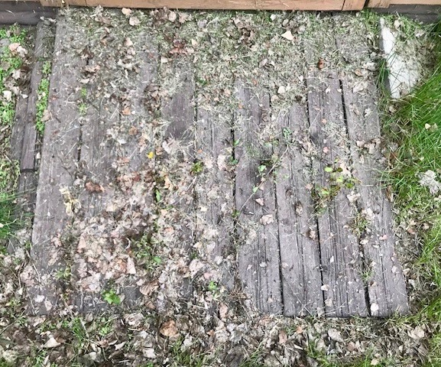
Photo 2:
This is the same spot of a photo from Creative Practice 1, at my cabin in Collingwood Lakeshore Estates; however, this photo was taken before the other version when the plants between the boards were alive and the debris from the winter has been blown away.

Knowing that there was debris here before there was growth of plants (in Creative Practice 1) reminds me of knowing the origins of sexuality. Sexuality, and sexual shame, is historical, and by understanding this history and queer theory, conversations can become more meaningful with the right information. As well, knowing students' prior knowledge and how they understand sexuality can lead to having successful conversations in schools. As Robinson (2001) writes, “Understanding the origin and maintenance of one’s values, attitudes and biases is thus a focus of this process of deconstruction” (pg. 123). In order to deconstruct false assumptions about queerness and sexuality, teachers must ask themselves, students and parents why they have certain beliefs. This will help one to realize the point within their cycle of thinking where they have been misled to believe something that is based on assumptions alone.

I was surprised at how unappealing this ramp looked after the winter; dead plants between the boards, dead grass on top, scattered leaves and it is all trampled down. This reminded me of how it feels to be shamed; do not want to be seen, humiliated and discouraged. I think that no one would agree that shame feels good, so this photo represents negative thoughts about ourselves and our actions that surface due to feeling shamed. I also view the trampled down plants as something that I may have contributed without knowing, similar to how I may shame my students without knowing it in the moment, but I must be aware of how shame can occur unintentionally.

By noticing this ramp and the debris that had accumulated on it, I was able to clear it so that the ramp could be left alone and decluttered, therefore, I changed the quality of the ramp to make it appear more beautifully (clean, allow plants to grow). This translates into noticing that when I feel shamed, to attune to how it makes me feel and try to reverse it, similar to sweeping my thoughts away. I offer the ramp in the photo an opportunity to be cleaned to let the plants grow between the boards, and it offered me a photo of beauty in Creative Practice 1 as well as a sense of reflection and consideration of how I can relate to it.

This photo could also represent sexuality in that society loves to categorize sexuality, as the boards may represent. Society categorizes based on criteria, the leaves, that fall into each category; however, life is not this simple and cannot be categorized easily. The criteria/leaves overlap from one category to the next, which complicates the ideas of sexuality, including how LGBTQ+ people are misinterpreted based on assumed criteria and misconceptions.

Photo 3:
This is a photo looking out the window at 13th Avenue Coffee House in Regina.
I have never taken the time to look out this window because I suppose I assumed that the view would not be very good, after all, I know that there is a patio, a road, and church across the street. But perhaps there is more to these things that I see at first glance.
Similarly, as a teacher I must put my assumptions aside about students, their gender and their sexuality. If I take the time to get to know students and who they truly are, while agreeing to love them unconditionally in my classroom, I can have a better relationship and understanding of each child.

Looking through a window means that I cannot see everything that is outside the building. This is similar to looking through the normative heterosexual lens. As a teacher, if I look through a heterosexual lens and assume all my students are heterosexual (Robinson, 2001) and that their biological sex aligns with their perceived gender, then I will miss part of the picture and part of their identity. By putting aside my assumptions, I can better teach about sexual and gender diversity to support all students in their exploration.

I noticed that the photo of this window was taken slightly to the left, so the window is not viewed straight on. When I realized this I immediately thought of Michele’s visual with her hands of what is norm and what is the other. The normal is a certain way, “straight” up and down. When the norm is tilted just a little, that is the other. Society does not like anything that is different than the norm. For example, Warner (1999) writes, “the world was homophobic before it identified any homosexuals to be phobic about” (p. 6). This highlights society’s natural aversion to differences of any kind, but if I advocate for those that are queer, and encourage others to do the same, perhaps a tilted view will become the norm. In other words, perhaps “the loathing for queer sex, or gender variance, will no longer distort people’s lives” (Warner, 1999, p. 39). As a teacher I must not look through a lens of the norm to teach my students about diversity.

This photo also sparks my recent love for plants, especially succulents and cacti, and photography in general. Also, this photo I find to be very aesthetically pleasing, therefore, this photo brings me peace, comfort and joy when I look at it. This affects the quality of the window and plants by being noticed and deeply appreciated by me.

Photo 4:
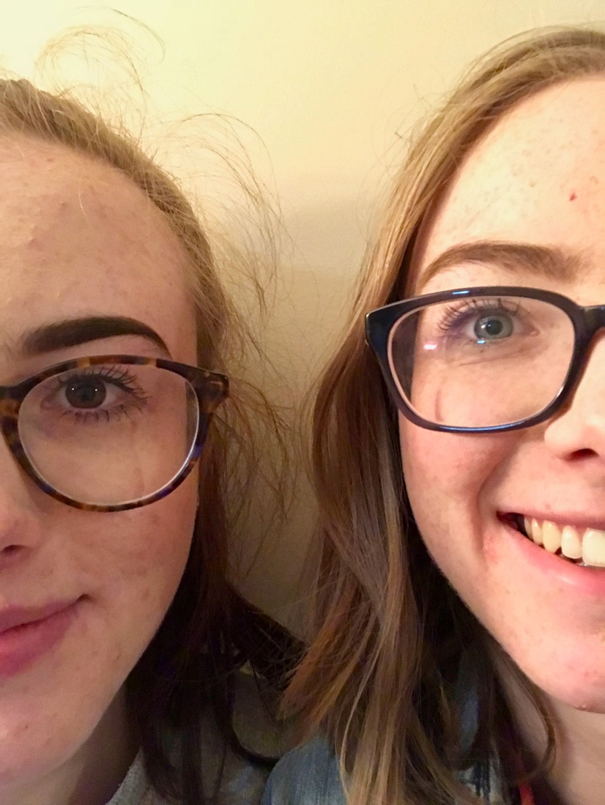
This is a picture of my younger sister, Arden, and I.

To me, this photo represents what is seen by others versus what may be the truth. According to society, we both may look heterosexual as oppose to lesbian due to our appearance (long hair vs short hair, modern glasses, feminine vs masculine, etc.); however, this is only based on assumptions of what people in a certain sexuality group look like. Furthermore, we may look like females, but outsiders do not know what we feel or what genitalia and biology we have. As Warner (1999) writes, “heterosexuality is often a name for the entire package, even though attachment to the other sex is only one element” (p. 38). So, if people assume we are heterosexual they usually also assume we are females, desire masculine men, desire only men, have female chromosomes and genitalia, and the list goes on. Since our “gender conforms more to the norm [we] can often be silently accepted” (Warner, 1999, p. 37). Society views us based on assumptions but do not know us as people.

In class, when Michele asked how we try to control others, I immediately thought of trying to control my sister in relation to her sexuality, so this photo takes me back to those same thoughts. I advise her how to dress, to use birth control, not to be promiscuous, only to have sex in her dating relationship, etc. and in other ways; advising her what classes to take, reminding her constantly to do her homework, asking favors, etc. I have tried to control her because I know she would rather listen to me than our parents and, I suppose, because she is still considered a child. She has just entered adulthood this year when she turned 18, but before she would be viewed as a child, and thus, a “’not yet’ citizen” (Gilbert, 2014, p. 4) in which I, an adult, could try to guide her as best as I can. I wonder if she considered herself a citizen before turning 18 though. She now has rights that children do not, so, perhaps, I need to allow her to make her own decisions.

By noticing my sister and I in this photo as two close beings but also two different individuals, I notice the strength as well as the limits of our relationship. I notice how I affect and treat a child, nonetheless, a child that I am close to. This acknowledgement can allow me to change my behavior, which will affect my sister by receiving different behavior from me.

References
Gilbert, J. (2014). Sexuality in school: The limits of education. Minneapolis, MN: Univ Of Minnesota Press.
Robinson, K. and Ferfolja, T. (2010). ‘What are We Doing this For?’ Dealing with Lesbian and Gay Issues in Teacher Education. British Journal of Sociology of Education, 22:1, 121- 133, DOI: 10.1080/01425690020030828
Warner, M. (1999). The Trouble with Normal: Sex, Politics, and the Ethics of Queer Life. NY: New York: The Free Press.

