Photo 1:
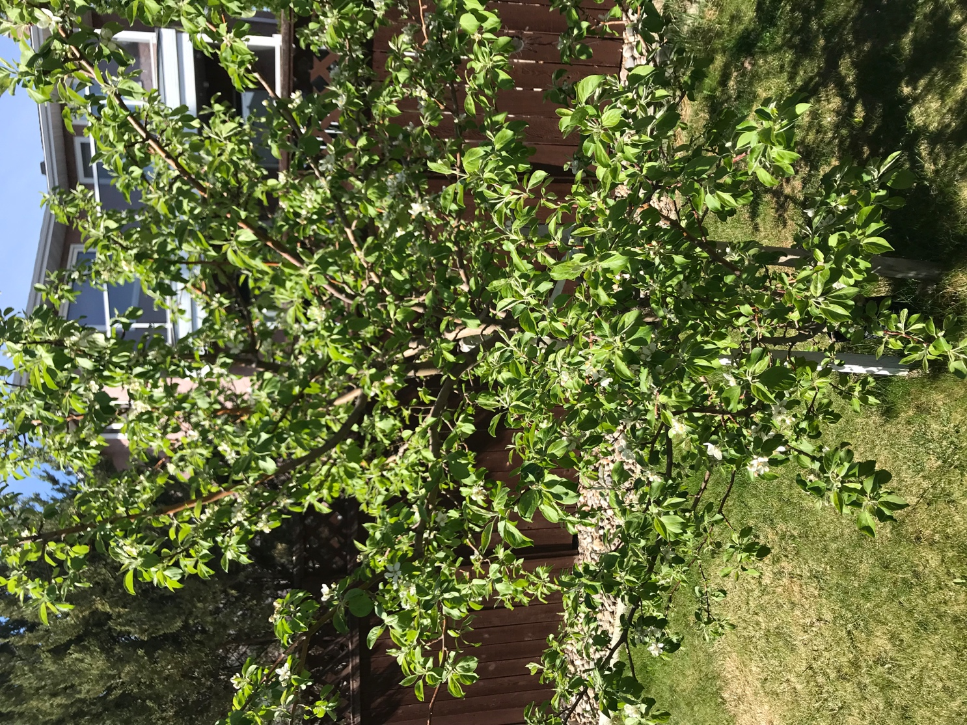
This is a photo of a crab apple tree in my backyard in Regina from a standing perspective.

I have known that this tree has been in my backyard for many years; however, by noticing the tree in this moment where the flowers are starting to grow, I realize that I have only noticed the tree previously when it has many apples growing on it. Sometimes I even notice the tree and its apples when the apples are producing so rapidly that the apples are on the ground because my Dad will mention that they need to be picked. I think this is significant because I notice the tree when it has something materialistic to offer. I have failed to realize the growth and beauty of the tree as it goes through the process to produce the apples that I love to eat. I have taken for granted what the tree has to offer.

This tree reminds me of a child. As teachers we are supposed to teach “the whole child” but we still ignore their sexuality, as discussed in class. I see the blooming flowers as children’s sexuality because both the flowers and sexuality are evolving and changing over time and both are the way they are just because; the tree did not choose the color of flower it produces, and humans do not choose their sexuality. As well, I have ignored both (children’s sexuality in some ways, and the flowers) until this moment and in this class. Even then, I have been told to notice something new in my daily life, and similarly teach about sexuality, so my notice of these things is forced in a way. Furthermore, the sexuality of a human can be a beautiful thing when it is acknowledged, embraced and not shamed because it is part of the person. Therefore, by noticing the tree’s flowers and, children’s sexuality, I am doing a favour to the identity of the entire being. I am allowing the tree, and the child, to be themselves, without shame and with love.

On the contrary, the flowers can also be seen as opposite of a child’s sexuality in that the flowers cannot be shamed, but sexuality can be shamed. If I shame the flowers for not being full bloomed yet, or not white enough, or any other reason, they will not feel the effects of shame at all; however, the child will. The child may feel humiliated, redirected, discouraged, belittled and change their behaviour in accordance to what is “appropriate” and not shameful. Whereas, the flower will continue on growing.

Photo 2:
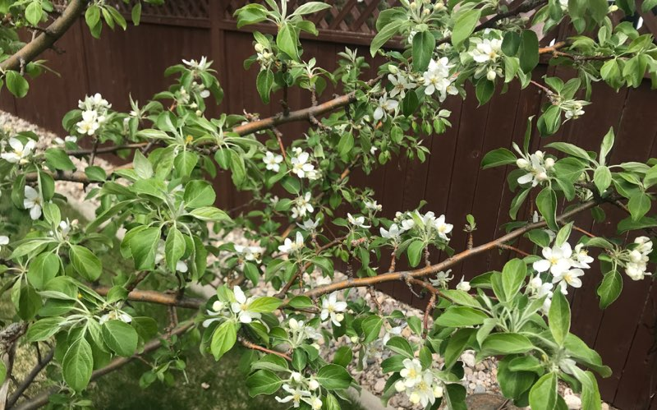

This is a photo of the same crab apple tree, close up, to emphasize the flowers even more so.

The tree has offered its beauty for me to admire, and by acknowledging it, I am fulfilling its purpose. I gain a beautiful sight of flowers and can share this view with my family by encouraging them to also look at the blooming flowers. It makes me wonder how long the flowers have been blooming for and when they began to bloom. Perhaps I have been missing their beauty for quite some time.
I also appreciate how simple, small and delicate the flowers are. Life can be very chaotic, busy and complicated, but thinking of these flowers may help keep me grounded in the future. The flowers are a reminder to me to enjoy simple pleasures in life among the hustle and bustle. Furthermore, the flowers are vulnerable. I think it is natural for humans to be vulnerable, including myself; this photo reaffirms that vulnerability is acceptable.

Continuing with the previous analogy of the flowers representing children’s/human’s sexuality, the close-up angle of sexuality represents non-heterosexuals being put under a microscope and analyzed because they are different from the norm. I could analyze and become skeptical of the flowers, but this would not be beneficial to them or to myself. The flowers are simply being themselves. This makes me wonder why we interfere and question homosexuals, lesbians and the rest of the LGBTQ community when instead, society could just let them be. I think the flowers want to be noticed and appreciated, as all humans desire; however, the flowers/humans do not want to be looked down on, investigated, or, most of all, shamed.

Furthermore, there are gaps in sexuality, similar to how there are gaps in the leaves where there are no flowers growing yet (specifically, left side and bottom right). This represents that there are gaps in sexuality, opportunities for new experiences and new knowledge, and that sexuality is fluid. Perhaps, the flowers are what is seen by others, and the gaps hide sexuality (maybe some flowers are hidden behind the leaves) in certain places, like in public, due to fear of shame.

Photo 3:
This is a photo of the ramp/walk way up to the shed at my cabin in Collingwood Lakeshore Estates.
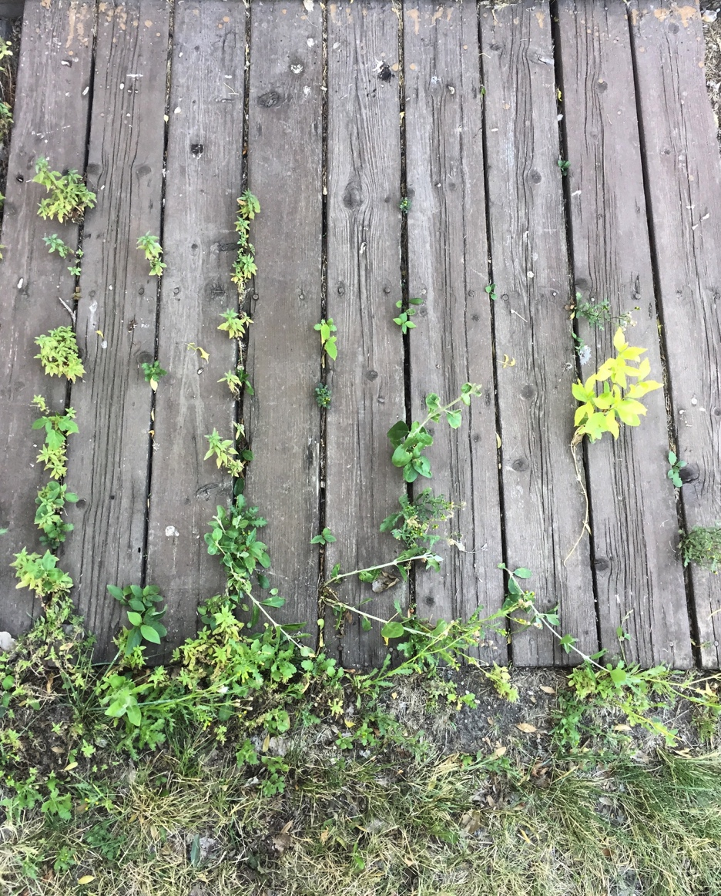
I have walked by this ramp every time I pass the shed for the last 12 years and have just noticed the growth of plants between the wooden boards. I think that the plants want to be noticed, and do not want to be concealed underneath the wooden boards any longer. I am helping these plants fulfill their purpose to be seen and acknowledged. Also, by noticing the plants I am simultaneously acknowledging them to be able to grow in the forced circumstances between the wooden boards, and I can do everything in my power to help them continue to grow. This reminds of having queer students in the classroom; the teacher must help the students grow in the forced circumstances of a heterosexual society in whatever way that may include. As well, teachers can make sexuality and gender variance an acceptable and welcoming conversation with students.

In return for the plants providing me with a beautiful sight, I can provide them with water to ensure that they keep growing. I can also be cautious when going into the shed as to not step on the plants in order to allow them to continue growing. By giving the plants the right circumstances to grow in, I am acknowledging their independence and ability to thrive in a given situation. I love taking photos of plants, so by noticing this adaptation of plants I get a sense of peace and deeper admiration for them.

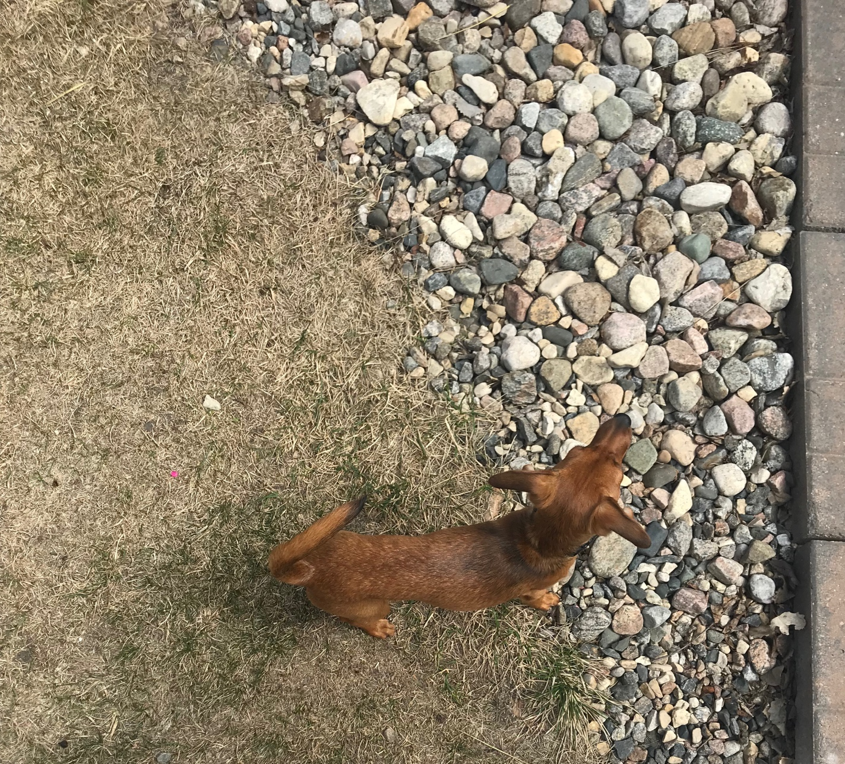
Photo 4:

This is a photo of my 6-month-old puppy, Lea, in my backyard.

I noticed that since my family got Lea at 3-months of age, she has physically matured as she’s grown older, she has more black fur on her body as oppose to light brown. In spots that used to be mostly brown, like her back, tail and ears now have black furl. I have seen her every day for the past three months, so these changes are difficult to notice, but those that see Lea less often have confirmed these physical changes. I wonder if my family thinks that she has not changed as she’s grown older. The perspective is important. The picture represents perspective too by the angle of the camera above Lea and the contrast of grass, rocks and patio blocks. This reminds me to keep in perspective my loved ones, like Lea, and our relationship. I think that by seeing this physical change, I am acknowledging that she won’t be a puppy forever nor always be playful or be able to jump up on the couch, so I must not take this time for granted. Often, I think relationships with others pass by quickly if one is not attuned to, and people change. I want to be more attuned to my relationship with Lea and make sure not to take it for granted but rather be in the moment.

I offer time spent with Lea; including playing, providing her with food, water, shelter and love. She gives me unconditional love in return. She also is a stress reliever in many ways; she wakes me up early so I can get things done, she makes me take breaks during homework to play, and having her around is calming. Lea keeps me grounded and allows me to focus on the present moment.

This photo reminds of a teachers’ job to be aware all the time; of students’ identity, to students’ words and actions and know how to talk about sexuality in the classroom. The students and teacher have a relationship in which both provide something for one another. Lea’s change of coloring represents her change of identity. If a students’ identity, sexuality or sexual autonomy changes, the teacher should honour it and reflect their identity back to affirm their being.

