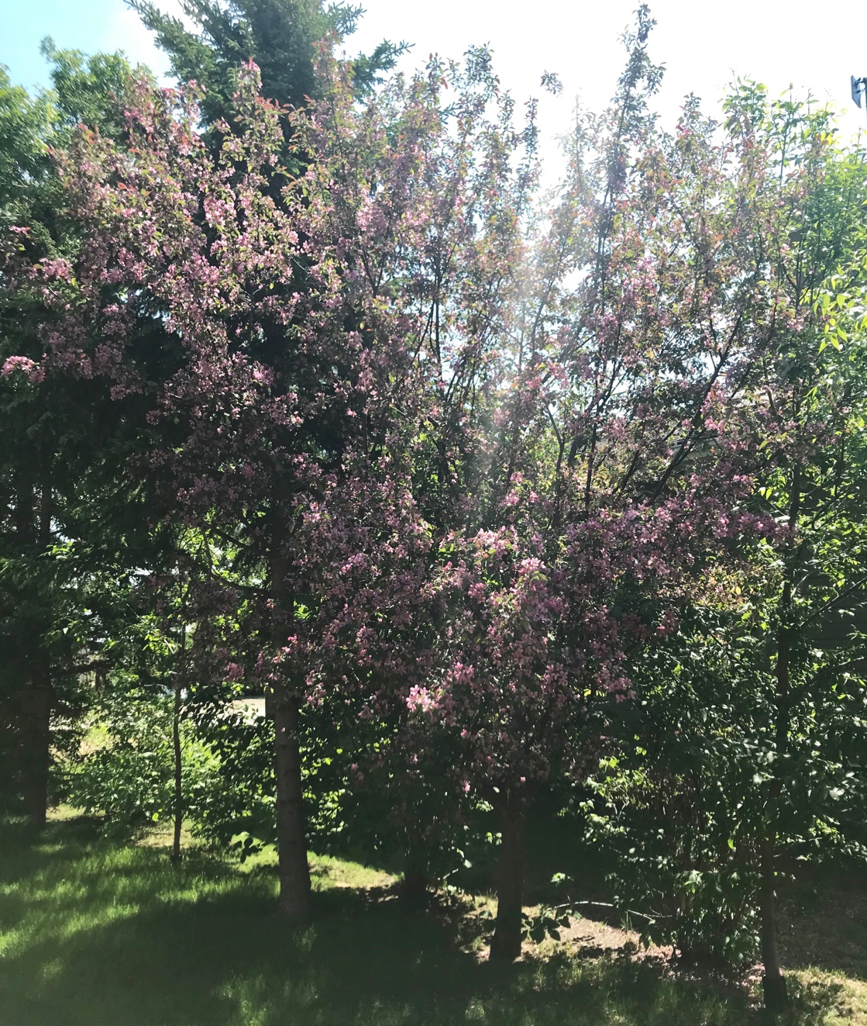
Photo 1:
This is a photo of a tree at my cabin near the main driveway. My family believes that this tree is for ornamental purposes and does not produce edible fruit.

I did not know that this tree was here until taking this photo. Perhaps it has gone unnoticed by me because of its ability to hide among the other trees that surround it, or perhaps I have never seen it in bloom, like in this photo. Its blooming period is short, therefore, could easily be missed. I noticed this tree after there was a lot of rain, so I think that the rain gave this tree the encouragement and necessary water to bloom, grow and be noticed. By being noticed, this tree has become beautiful. In return, this tree provides me with a beautiful view of seeing pink and purple tones among a sea of typically green plants. To further affect this tree, I can provide the tree with water when it is dehydrated, I can continue to see it and acknowledge its beauty (even when it has not bloomed) and express its beauty to others to repeat the cycle of affect. I especially love that this photo captures the sunlight coming through the trees. This is something that I also have not noticed among these particular trees before.

The trees in the vicinity make up this particular tree’s assemblage. Within this assemblage, this tree can be colorful, provide beauty, stand tall, and contribute to protecting the others from wind and harmful weather and can be vulnerable to similar elements. Perhaps if this tree had other assemblages, its affect on me may be different or vice versa, or it may act differently, or be treated differently by its surrounding trees. I can also change the assemblage in which this tree lives in if the assemblage was a hinderance. This reminds me of a quote that a classmate mentioned in the class on June 5; “When a flower doesn’t bloom you fix the environment, not the flower.” The same is true for queer students, I do not wish to “fix” the queer body but rather fix the environment and assemblage to help the individuals thrive.

While writing this, I asked my Dad about this tree to clarify what it is and if it produces fruit; I wanted to know because of the little attention I have given this tree before. This question reminds me of humanity’s need to categorize/pathologize everything, as I needed to know what the tree is able to do or not do. Robinson and Ferfolja (2001) describes this as “demonstrating the pathologizing of the individual [tree] who is different or who stands out because of their failure to comply with … constructions [of what a tree should provide] and associated expectations” (p. 129). Society, including myself, wants to know the correct categorization due to biology (if the tree can produce fruit) and other factors. Furthermore, when my Dad and I were discussing the tree, my mom said it’s a “shame” that this tree does not produce fruit because it’s a “waste” of a tree. This attitude is reoccurring regarding when attractive males are gay because heterosexuals, the normative sexuality, cannot enjoy the sexual company of the attractive male due to his sexuality. As well, this “wasteful” attitude happens when women have intercourse and do not get pregnant because some view sex for reproductive purposes only. These views are based on the idea that the world is centered around humans, when, in fact, new materialisms change this. In new materialism, instead of the world being human-centered, there is a “‘web of forces, intensities and encounters’ between human and non-human elements [that] produce specific, highly constrained manifestations of sexuality … but also, importantly continual challenges, fragmentations and resistances” (Alldred and Fox, 2015, p. 907). The next time I see this tree I believe I will be reminded of the conversation that I had with my parents about it and the learnings that accompanied it.

Photo 2:
This is a photo of the flowers that have fallen off of the tree that I discuss previously.

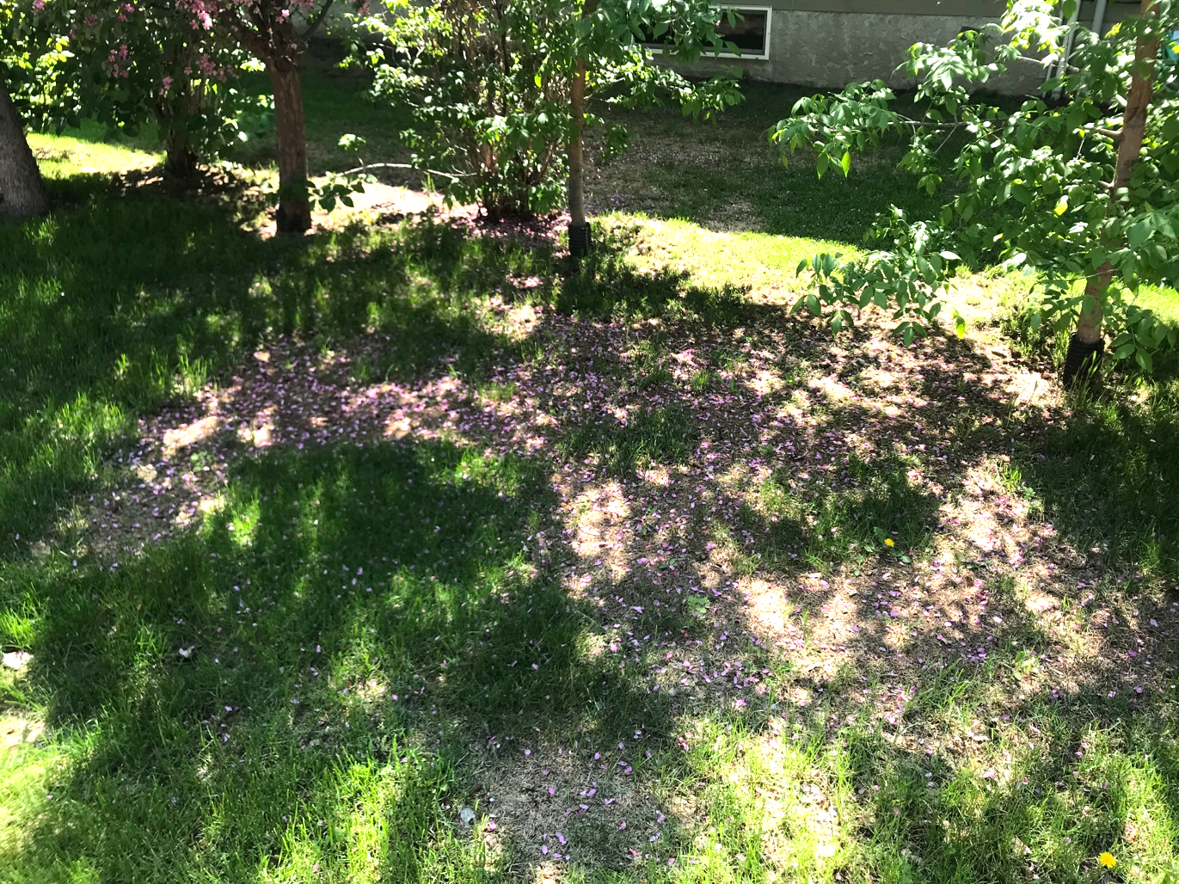

If I remember correctly, I believe I noticed the fallen flower petals that seem perfectly placed before I noticed the tree itself. By noticing the fallen flowers, I have recognized what the tree sacrifices in order to be beautiful and noticed. Furthermore, the loss of its flowers could be related to the shame of sexuality. Shame often makes one feel as though and they have lost a part of themselves by being told by society with words and/or actions that they should change. I see this as being similar to the tree losing its flowers. Perhaps the wind and weather have forced the tree to shed its flowers. I can try to affect the tree by shielding it from wind to protect it, or allow the fallen petals to grow another tree, if possible. This would encourage life and the ability to simply be as is. Although the tree will re-bloom every year, a child may not re-bloom the same way having already felt shame once. This experience and new identity illustrates students being territorialized and de-territorialized. Teachers have the power to de-territorialize students in positive ways; however, shaming students that forces them to shed a part of their identity is negative. This area of de-territorializing can be powerful or dangerous.

This photo also reminds me of the constraints society puts on sexuality, possibly represented by the natural constraints and rigidity set on where the flowers can fall, guided by the direction of wind and other trees standing in the way. Sexuality is controlled in schools by having dress codes, sex education classes typically only teach about heterosexual relationships and sexual encounters and limited forms of ways to have safe sex, and the list goes on (Gilbert, 2014). Teachers must reconsider how sex education is approached and taught in schools as to ensure to not put as many constraints on sexuality but rather provide students with the opportunity to think and make wise choices for oneself about sexuality in its various forms.

Photo 3:
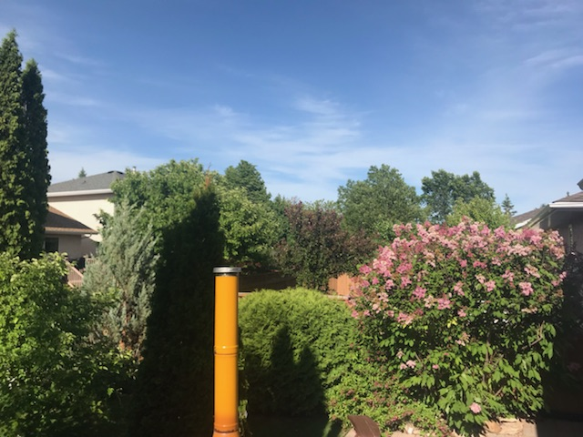
This is a photo of my backyard from a higher view that I usually see.

I found it the most interesting to see a top view of the lilac bush and trees. I have seen this top angle of the greenery before, but I have not seen it before; I have not internalized this view of the bush or thought about how it is so different from our usual standing view of objects. This is how this photo has affected me, by providing me with a new and beautiful outlook. This alternate perspective reminds me of teaching sex education; Gilbert (2014) and Michele suggest that there is more to sex education than the mechanics of how to have sex, there must be the involvement of thinking about one’s actions and metacognition. For example, Gilbert (2014) questions if “sex education can be a problem of and for thinking?” (p. 67). This means that questions in sex education can either be shut down, which they often are by educators and parents, versus how education can foster thinking and questioning about topics of sexuality. In any other subject, this would be the preferred way to learn, with questions, inquiry and engagement; however, these attitudes change in sex education due to the hesitance that surrounds the concepts. Sex education is negated, “‘defined more by what they hope to eradicate than what they hope to promote’” (Gilbert, 2014, p. 68). This idea relates to this photo in that it is encouraged to simply view the photo from a standing position because that is probably the norm and the easiest option. Similarly, teaching the mechanics and basics of sex education is the easiest option for teachers because it is not as risky. Taking the non-normative approach positively affects students’ learning and mine as well in seeing and appreciating a view that I wouldn’t normally see.

Furthermore, Gilbert (2014) argues to embrace controversy, comparable to an alternative higher-view of the greenery in this photo. She
“take[s] up the time of hospitality through … examples when queerness emerges as controversy and pushes against the limits of educational thought and practice [such as] debates about marriage equality, stories about transgender children and youth transitioning in school, and explicit representations of sexuality in a teacher education classroom” (Gilbert, 2014, p. 83).
Educators should always be embracing controversy as a hospitable choice, therefore, affecting sex education discussions to be easier, more real for the students, and “might make possible an education that welcomes queerness as both strange and ordinary in its manifestations and as quality of experience that could be made relevant for anyone” (Gilbert, 2014, p. 83). An alternative view of what we see, or alternative way of teaching sex education, pushes learning to be different and relevant.

Photo 4:
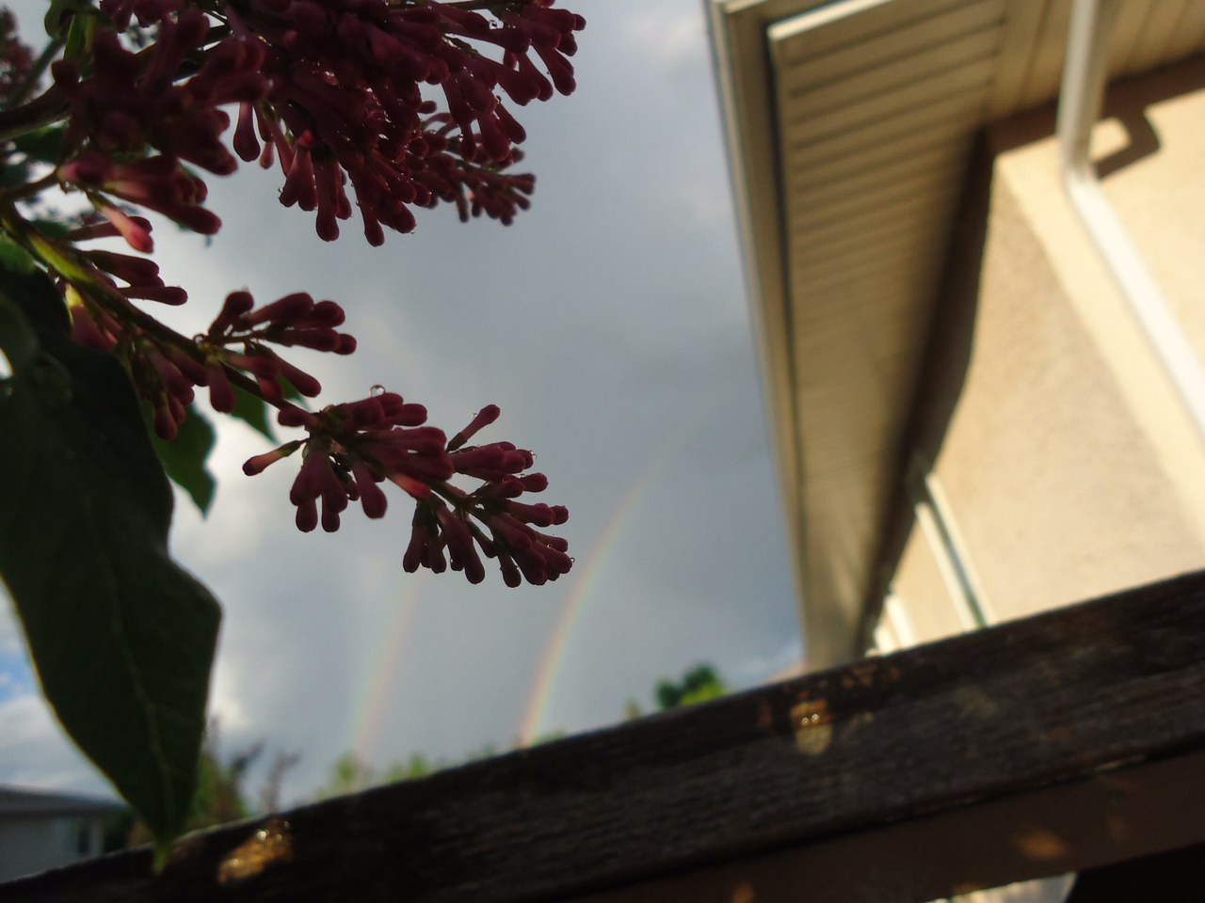
This is a photo of lilacs in my backyard from a underneath camera view. In relation to the previous photo, it is to the right of the lilac bush.

This photo affects me in that it gives me an alternate perspective from what I normally see, this will be discussed later. It also encourages me to think of how the alignment of what is in the photo are related and the impact that that has on me. I can affect the photo by acknowledging the beauty of the lilacs and double rainbow. These aspects of nature may be the focus of this photo for most viewers, but I can also affect it by drawing the attention to the other aspects, and to be seen as more than just one thing/image. For example, the photo can be viewed with the fence and house instead of only the lilacs, rainbows and sky. If I draw the attention of the photo as a whole to others, every aspect can be appreciated.

What stood out to me in this photo is the double rainbow. At a different angle/perspective, the rainbow may not be visible, or appear to be as significant to some, but it is noticeable to me. This may be representative of teaching students and being able to learn as adults to look at and examine what may not be as obvious at first. I think that Allen (2015) did an excellent job of representing this importance of paying careful attention to our surroundings in her article; “although mobile phones were not initially noticed by [Allen] as a researcher, nor spontaneously remarked upon by [student] participants, their recurrence in photographs and by implication their role in the production of sexuality at school could not be ignored” (p. 952). By taking time to notice what is reoccurring Allen (2015) was able to gain knowledge of how mobile phones affect sexuality, thus, affecting her students with this realization/gained knowledge too. Similarly, by noticing and internalizing this photo, my behavior and thoughts about nature’s beauty will change, and that may impact my teaching going forward. I can learn how to be more attentive to how sexuality is produced in schools, as Allen (2015) highlights by viewing my surroundings from a different perspective.

I see the two rainbows as representations of a student’s identity, including their sexuality. The rainbow to the right may represent a student’s fluid sexuality and the small rainbow could be the reflection of heterosexual’s identity that they see in society (Warner, 1999). The lilac that interferes and appears to stop the second (left) rainbow may represent the interruption that educators, parents, peers, and the rest of society takes control of in order to decrease and prevent LGBTQ+ people to be represented in society. This is a form of hatred by refusing to accept other’s sexuality. The reflection in society will always be there for heterosexuals and will always reinforce their identity; however, the true is not same for LGBTQ+ students.

References
Alldred, P. and Fox, N.J. (2015). The sexuality-assemblages of young men: A new materialistic analysis. Sexualities 18(8), 905-920. DOI: 10.1177/1363460715579132
Allen, L. (2015). The power of things! A ‘new’ ontology of sexuality at school. Sexualities 18(8), 941-958. DOI: 10.1177/1363460714550920

Gilbert, J. (2014). Sexuality in school: The limits of education. Minneapolis, MN: Univ Of Minnesota Press.

Robinson, K. and Ferfolja, T. (2010). ‘What are We Doing this For?’ Dealing with Lesbian and Gay Issues in Teacher Education. British Journal of Sociology of Education, 22:1, 121- 133, DOI: 10.1080/01425690020030828
Warner, M. (1999). The Trouble with Normal: Sex, Politics, and the Ethics of Queer Life. NY: New York: The Free Press.

